Attaching an AI Ready Compliant Invoice in Appraise-It

Prior to beginning this process, verify you have installed the latest Appraise-It and AIReady patches. These can be downloaded and/or purchased from http://www.sfrep.com.

- First, open your report. From the Contents menu, select an Invoice. Depending on your report it may be listed under any one of the Additional Addenda menu items.

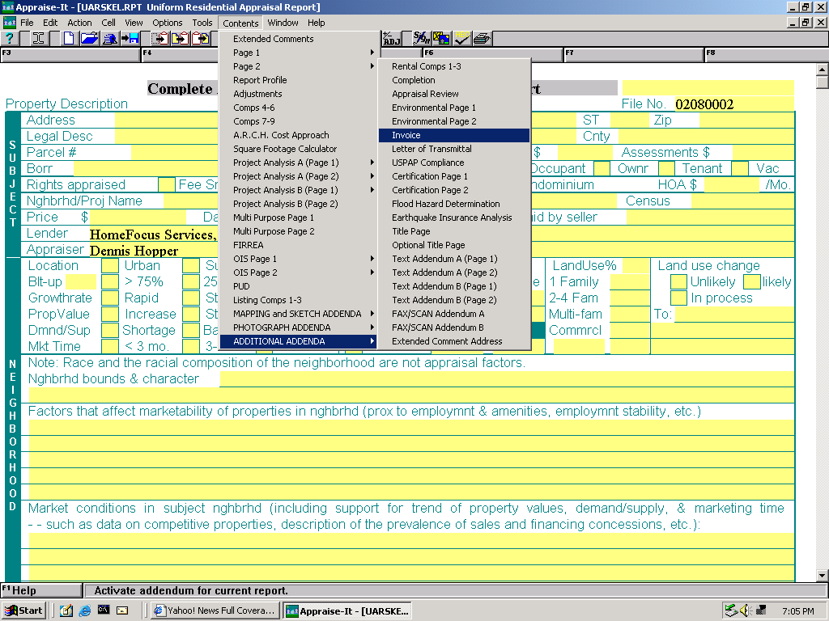

- After selecting the invoice menu, the Invoice will appear. Simply fill it out. Make sure your invoice number and fee fields are filled out correctly.

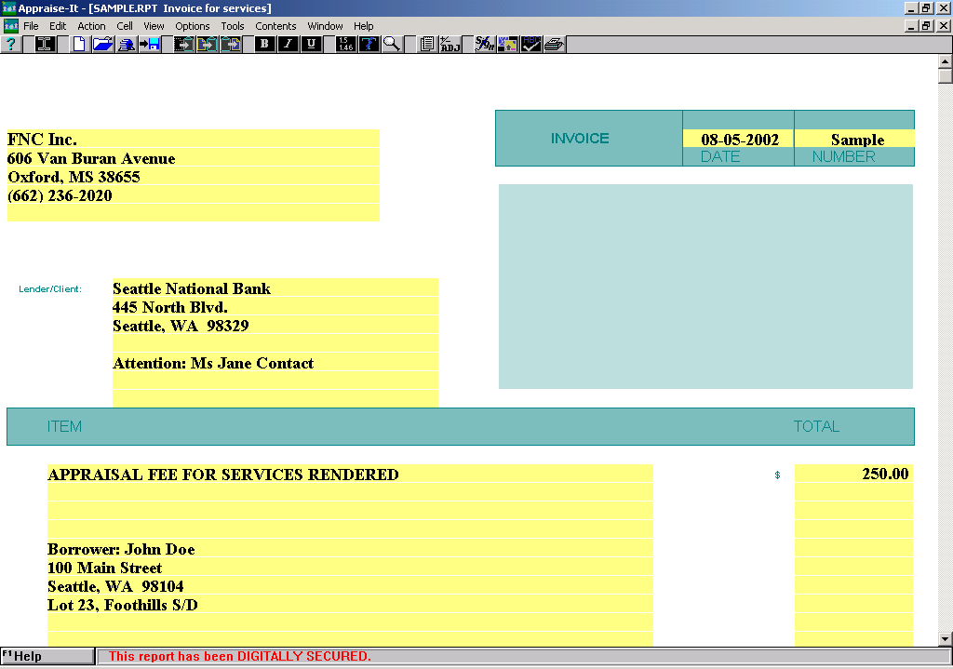

- When done with the Invoice, you may save the file. Now you are ready to upload your report.

- To upload your report from within Appraise-It, go to the Tools menu then click on AIRDPort/AppraisalPort. A box like the one below will appear. Click on the large button under Envelope Uploader labeled “Submit a Report to AppraisalPort and/or AIRD”.

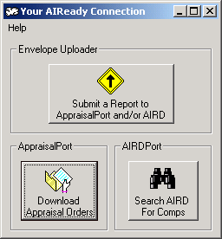

- An Open Report File box (shown below) will open. Select the RPT file that you want to upload. Once you have selected the correct filename, just click Open and the Envelope Uploader will start up.

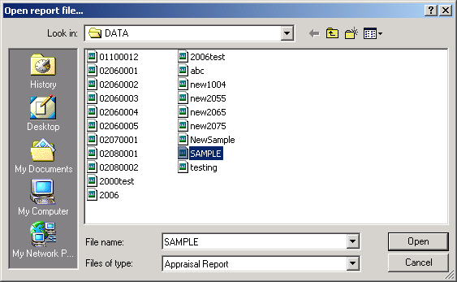

- Now you may view the invoice in the Uploader environment. To find your invoice, either click on Forms in the upper left-hand corner or click on the narrow toolbar on the left side of the screen to see the Invoice icon. (Make sure that the information is correct and shows up in the Uploader previewer.)

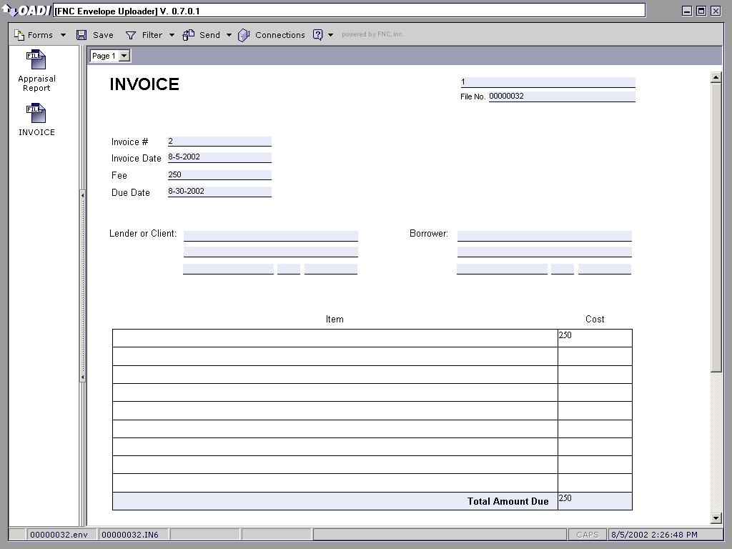

- You are now ready to send your report. To do so, click on the button in your uploader toolbar. This feature allows you to directly send your data to AIRD or AppraisalPort without having to open a separate browser.

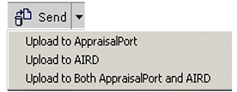

Attaching an AI Ready Compliant Invoice in Day One

Prior to beginning this process, verify you have installed the latest Day One and AIReady patches. These can be downloaded and/or purchased from http://www.day1.com.

- First, open your report. From the File menu, select Open Addendum. Or you may click on the “paper clip” toolbar button

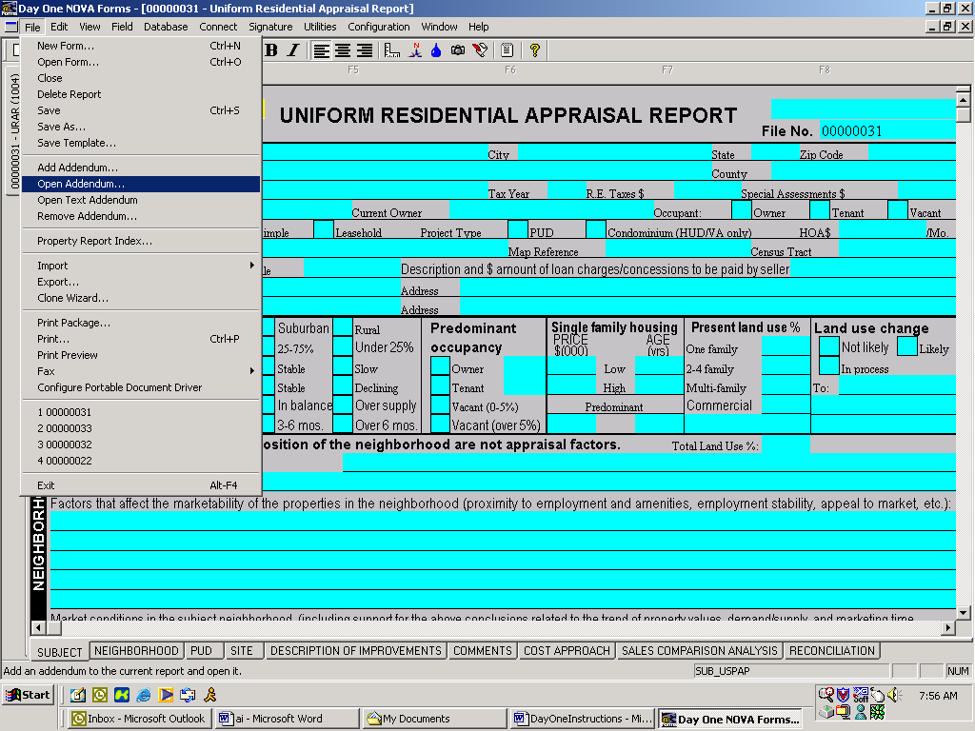

- The Add Attachment box will appear and you will need to select an Invoice under Available Attachments. After selecting an invoice, it should appear in the Existing Attachments box. Click CLOSE after the selection.

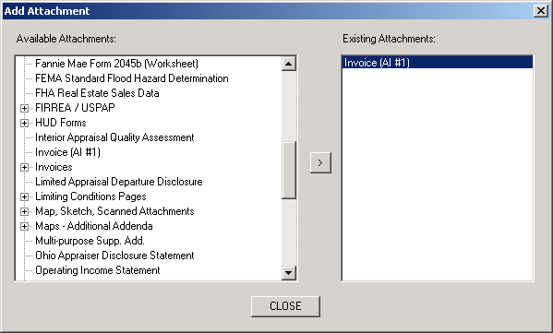

- Now you will need to go back under File and select Open Addendum. The invoice will be shown on the right hand side. Just highlight the invoice and hit OK. (If you choose the paper clip, your invoice will appear right after you hit CLOSE in the Open Addendum box.)

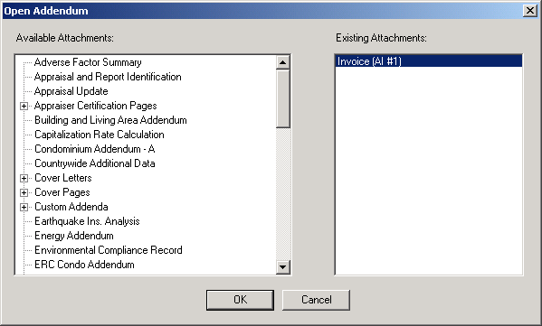

- After selecting the invoice, the Invoice will appear. Simply fill it out. Make sure your invoice number and fee fields are filled out correctly.

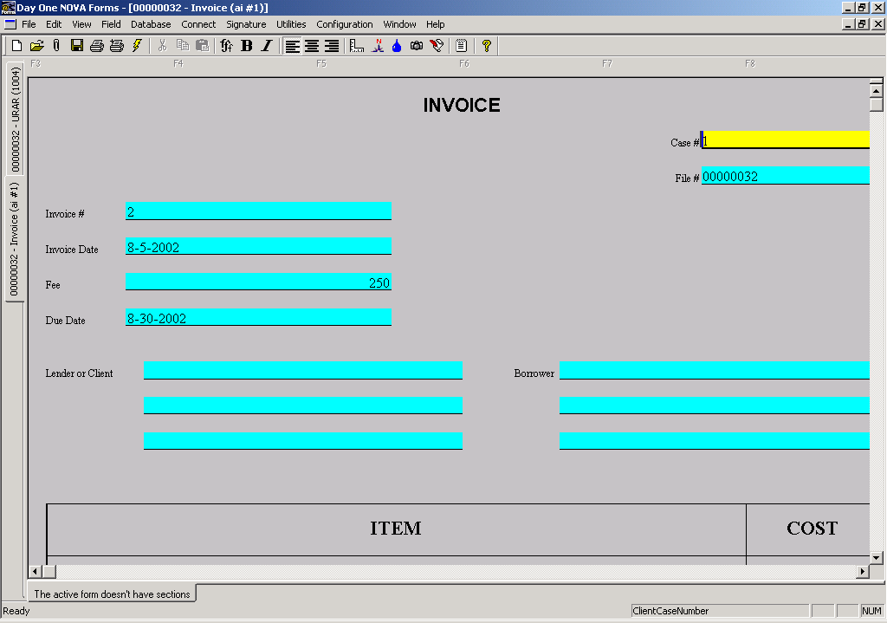

- When done with the Invoice, you may save the file. Now you are ready to upload your report.

- To upload your report within Day One, you will need to go up to the toolbar and click Connect. Choose Send Appraisal/Report and then select AIRD/AppraisalPort. The Envelope Uploader will now open up.

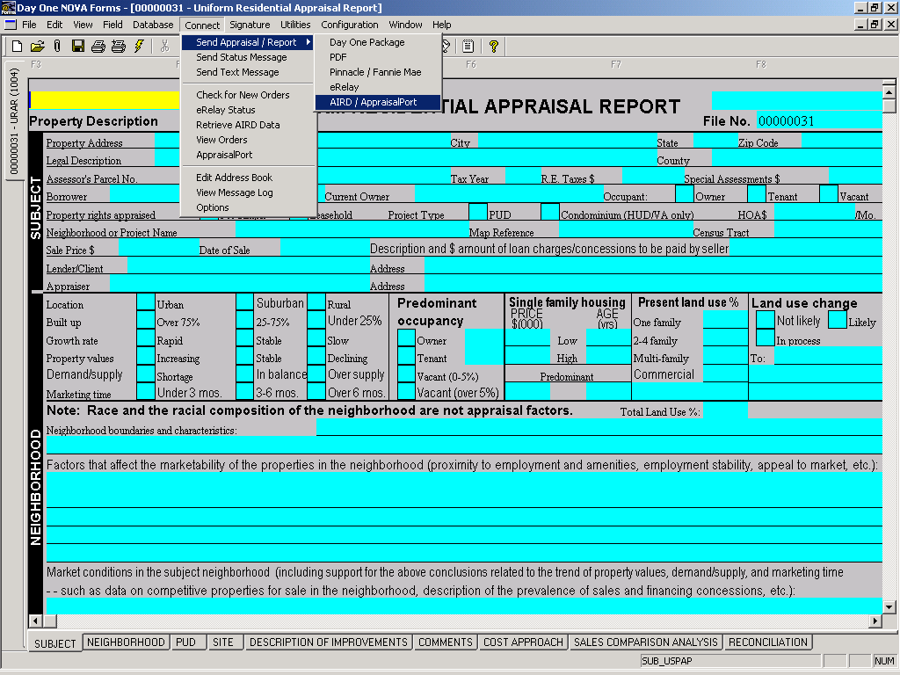

- Now you may view the invoice in the Uploader environment. To find your invoice, either click on Forms in the upper left-hand corner or click on the narrow toolbar on the left side of the screen to see the Invoice icon. (Make sure that the information is correct and shows up in the Uploader previewer.)

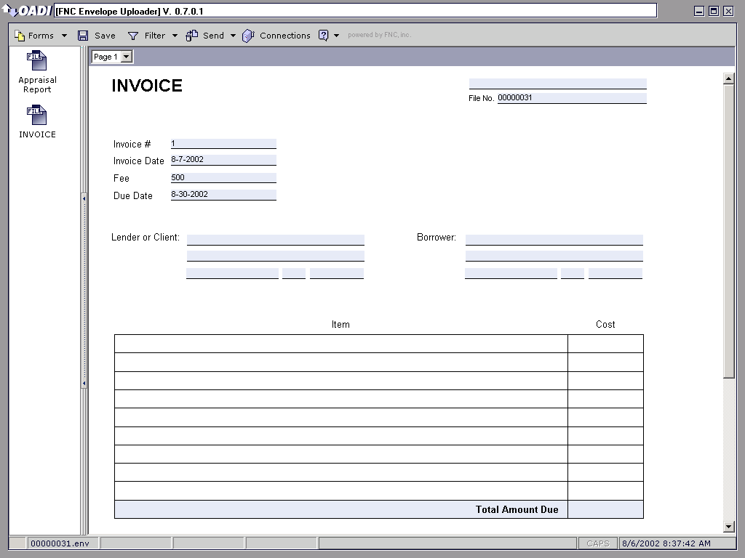

- You are now ready to send your report. To do so, click on the button in your uploader toolbar. This feature allows you to directly send your data to AIRD or AppraisalPort without having to open a separate browser.

Attaching an AI Ready Compliant Invoice in a la mode

Prior to beginning this process, verify you have installed the latest a la mode and AIReady patches. These can be downloaded and/or purchased from http://www.alamode.com.

- Open the report for which you want to generate an Invoice.

- Click on the Billing button in the toolbar. If you do not see the button, right click somewhere in the gray area and make sure that the PowerView Toolbar is checked. Or, you can go to PowerViews in the main toolbar and choose Billing.

- The Invoice will show up like the screen below. On the left hand side, you will see a drop-down menu of the different Invoice formats. Choose the one you prefer.

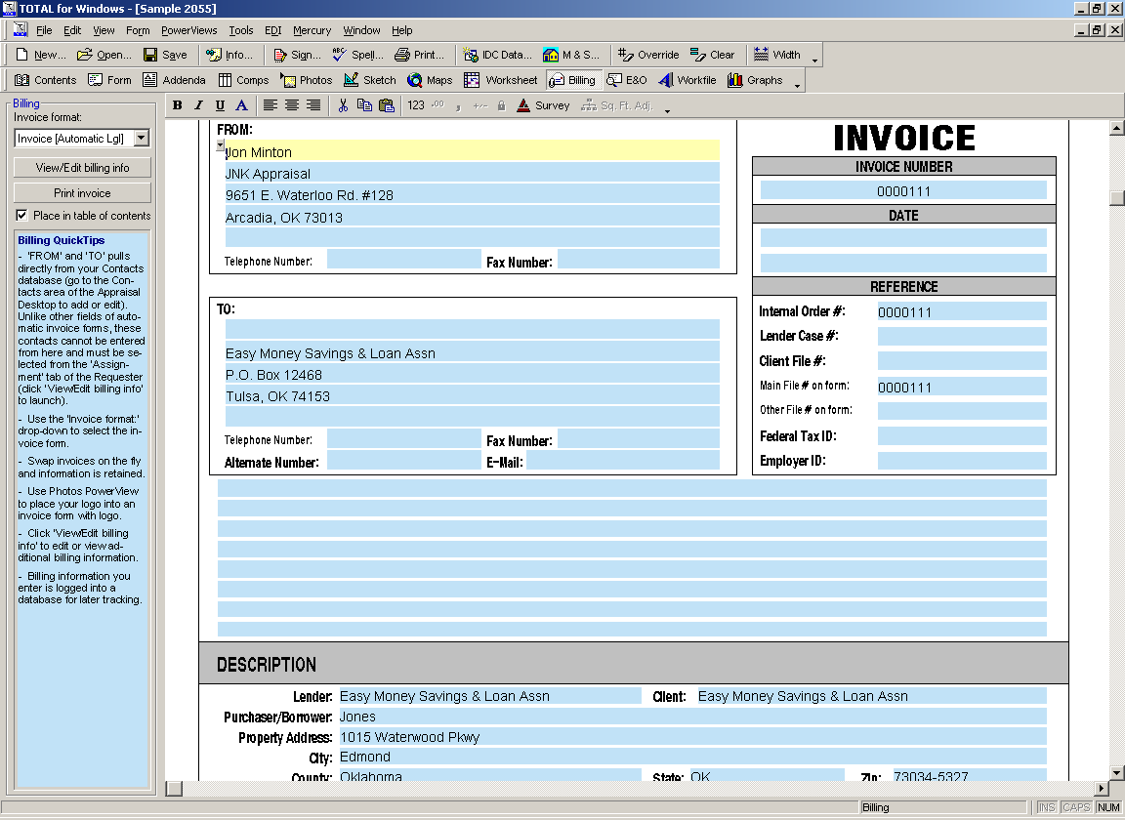

- After selecting the invoice menu, the Invoice will appear. Simply fill it out. Make sure your invoice number and fee fields are filled out correctly.

- When done with the Invoice, you should save the file. Now you are ready to upload your report.

- To upload your report from within a la mode, go to Mercury in the toolbar and click on AppraisalPort Wizard.

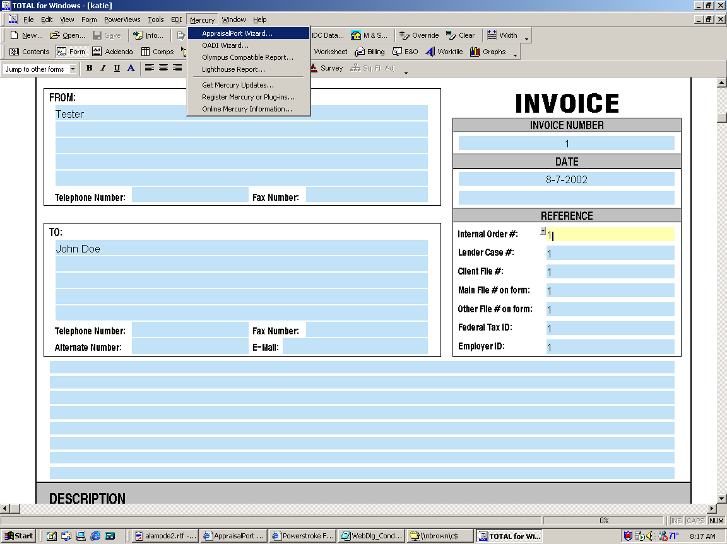

- The wizard box will appear like the one below. Follow the screens and just click Next until you reach the final screen where you will need to click Finish.

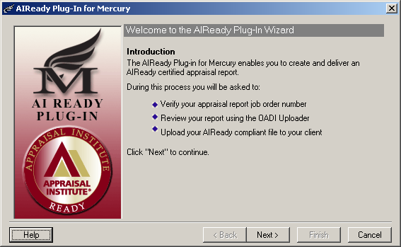

- Now you may view the invoice in the Uploader environment. There will be an icon labeled Invoice on the left-hand side of the Uploader. Just click on the icon and your invoice will open. Your screen should look like the one below.

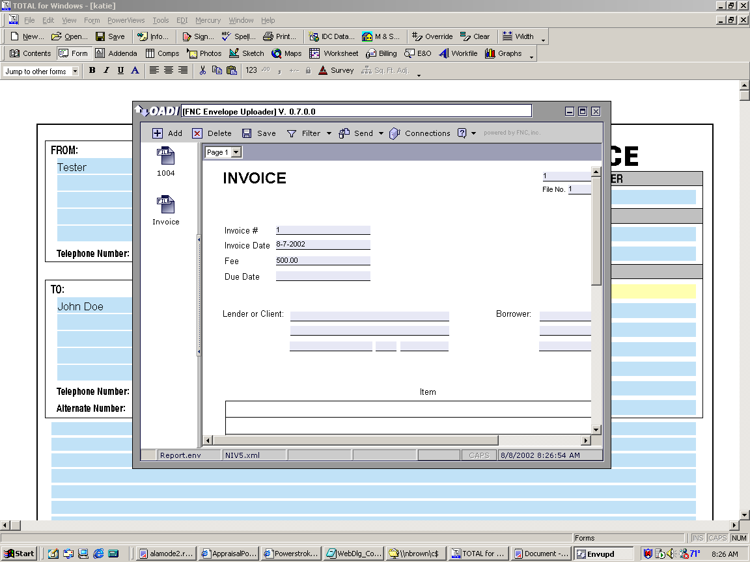

- You are now ready to send your report. To do so, click on the button in your uploader toolbar. This feature allows you to directly send your data to AIRD or AppraisalPort without having to open a separate browser.

Attaching an Invoice in the FNC Envelope Uploader

- Click on the Invoice button in the toolbar and click New.

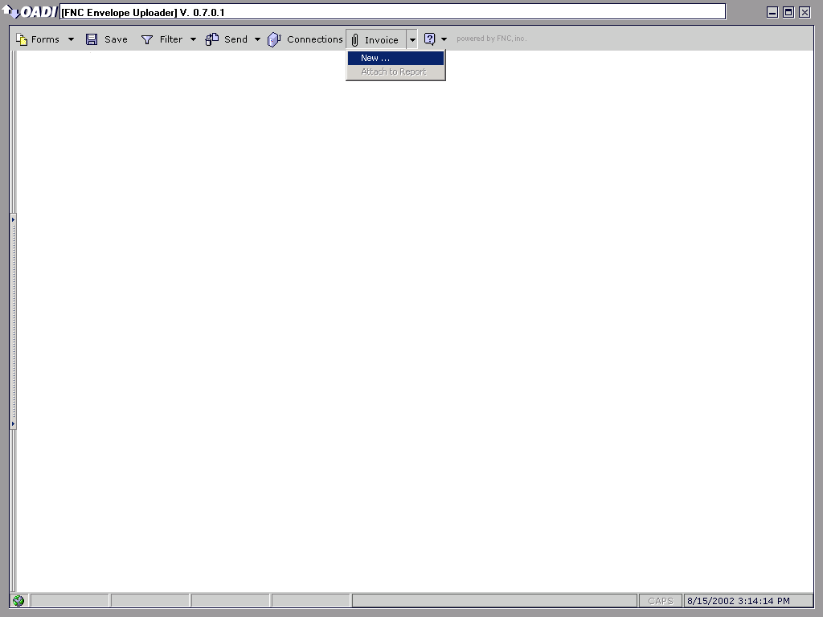

- A message box like the one below will appear. After reading the message hit OK and the invoice will open up.

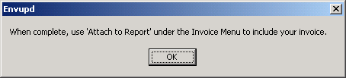

- Simply fill the invoice out. Make sure your invoice number and fee fields are filled out correctly. (They are marked with REQUIRED)

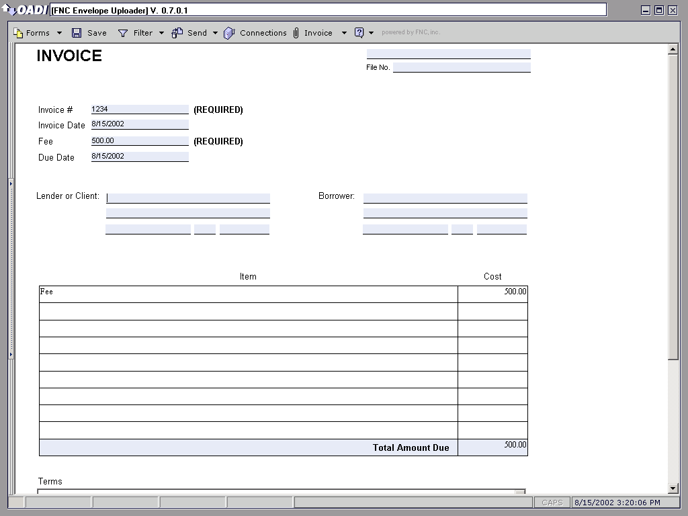

- Now you need to go back to the Invoice button in the toolbar and click Attach to Report.

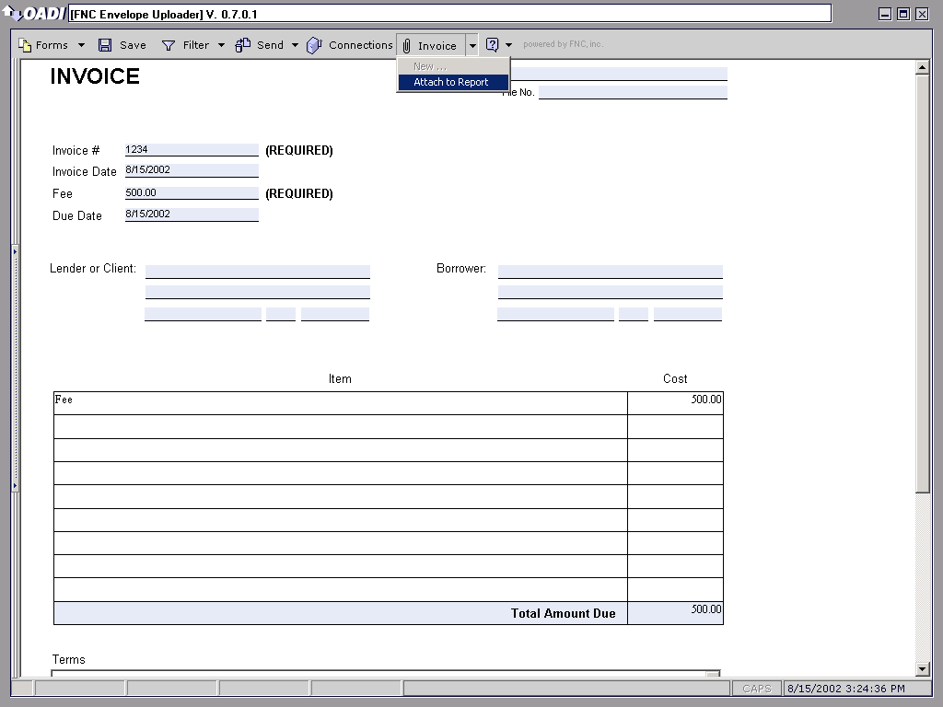

- The following message box will appear after attaching the invoice. Click OK, and you will be able to review the invoice by selecting Invoice from the Form menu.

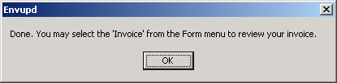

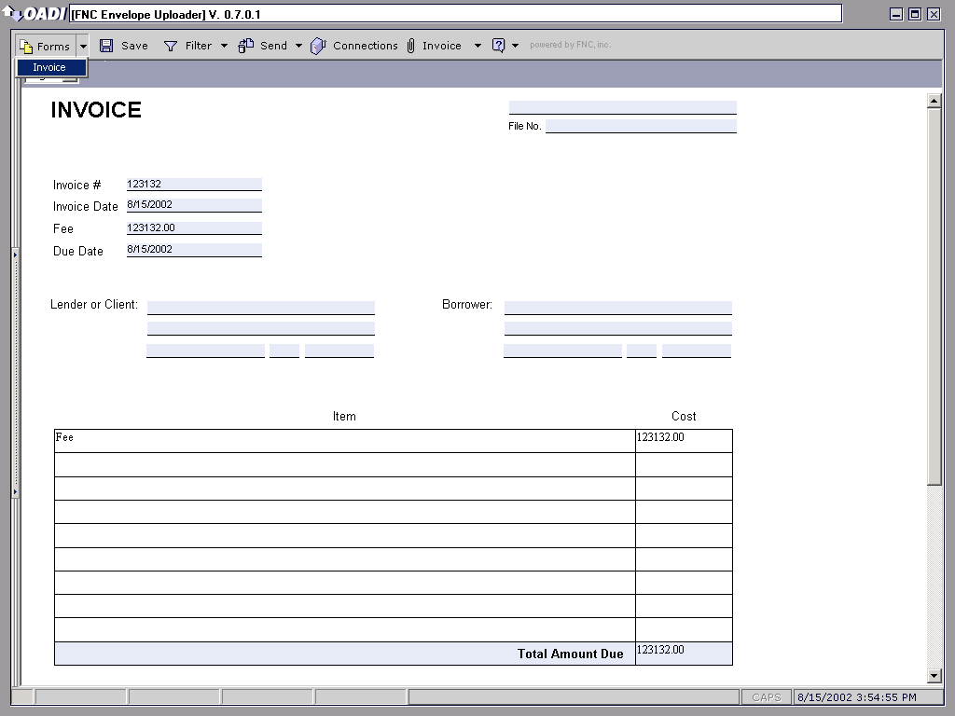

- You are now ready to send your report. To do so, click on the button in your uploader toolbar. This feature allows you to directly send your data to AIRD or AppraisalPort without having to open a separate browser.

Attaching an AI Ready Compliant Invoice in ACI

Prior to beginning this process, verify you have installed the latest ACI and AIReady patches. These can be downloaded and/or purchased from http://www.aciweb.com/.

- Open the report for which you want to generate an Invoice.

- On the left side of the screen you will see several icons of additional forms. Scroll down to the bottom and there will be an Invoice icon. Click on the icon and the invoice will show up like the one below.

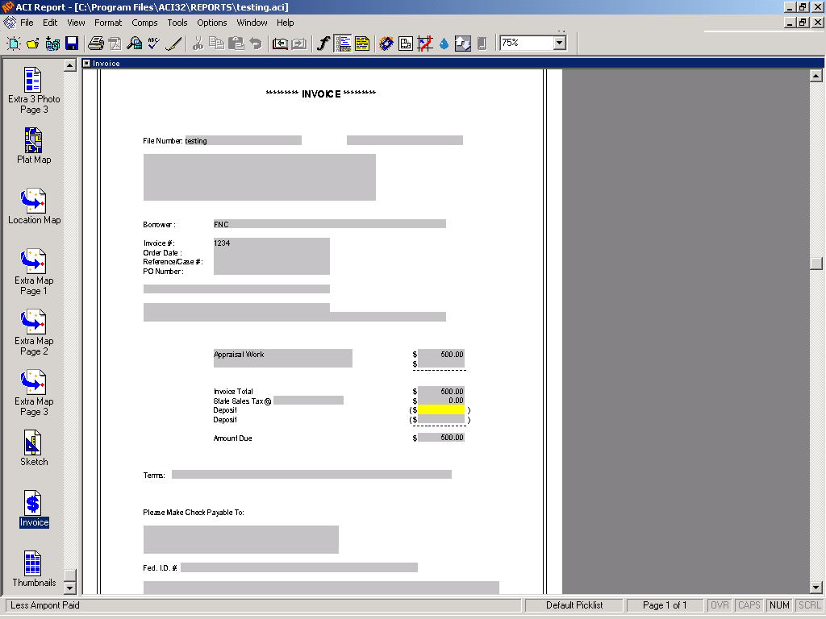

- Simply fill the invoice out. Make sure your invoice number and fee fields are filled out correctly or the Invoice will not upload.

- When done with the Invoice, you may save the file. Now you are ready to upload your report.

- To upload your report within ACI, you will need to go up to the toolbar and click File. Choose Send Web Services and then select AIRD/AppraisalPort. The Envelope Uploader will now open up.

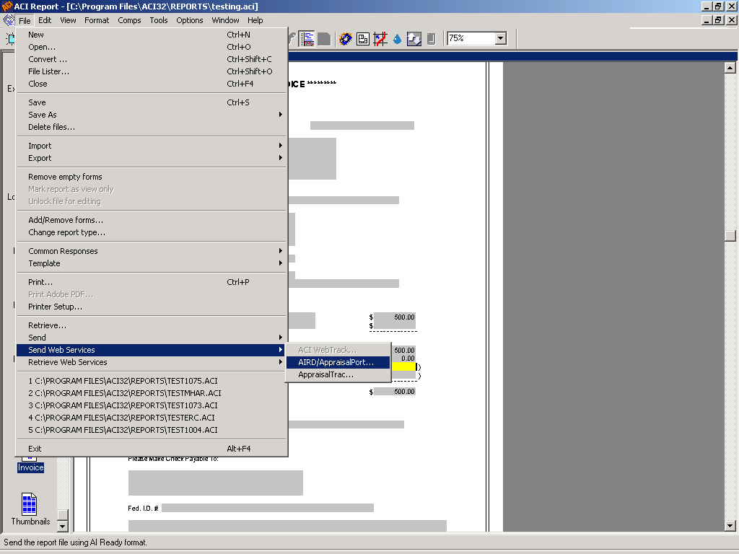

- Now you may view the invoice in the Uploader environment. To find your invoice, click on the Invoice icon on the left-hand side of the screen and the Invoice will appear in the previewer. (Make sure that the information on the invoice is correct.)

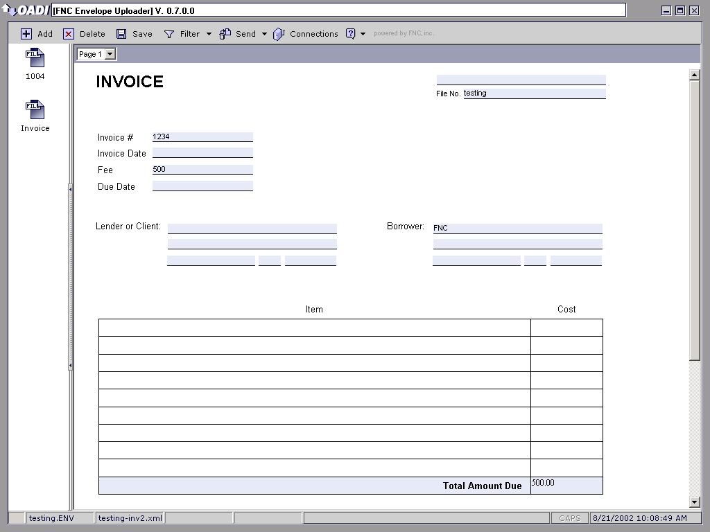

- You are now ready to send your report. To do so, click on the button in your uploader toolbar. This feature allows you to directly send your data to AIRD or AppraisalPort without having to open a separate browser.

